STOP THE DROP
As part of the Clean Up Yorkshire campaign Burncross Action Team is asking for your help in clearing rubbish from Burncross. We are encouraging you to join us in our regular monthly Sunday morning clear-ups, as well as urging everyone who is able, to do their bit on a daily basis.
If everyone in Yorkshire picked up one piece of litter, 2.5 million pieces would be removed every day.
Each able person in Burncross could pick up a piece or pledge not to drop.
The impact of littering is huge – our enjoyment and feelings of safety and happiness are affected when our environment is bad. Litter begets Litter.

Do you want BEAUTY SPOTS or GROT SPOTS?

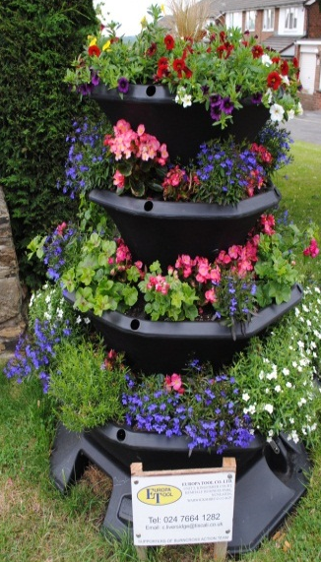 | 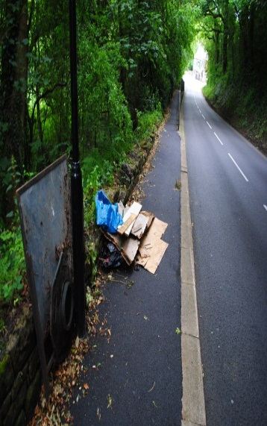
A big thank you to Bob Cox who tends to our new floral display. |  | Fly tipping on Hollow Gate
The cost to Yorkshire Councils in street cleansing in 2013/2014 was £77.1 million. The maximum court fine for littering is £2,500. Help us to improve the prospects for 2015/2016.

McDonalds (one of our sponsors) doing their bit.

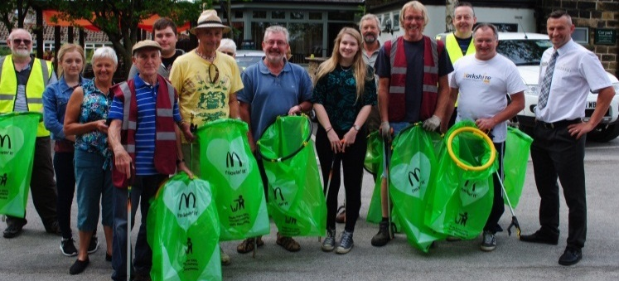

McDonalds sent along employees to one of our recent Sunday morning litter picks

Many thanks McDonalds for your on-going commitment.

Please contact us on www.burncrossactionteam.info or just come along to the Acorn car park to join us with our monthly clear-ups at 10.00 a.m. on the first Sunday of each month. BAT looks forward to everyone, who can, doing their best for the community of Burncross.

COUNCIL DEPOT AT THE TOP OF BRACKEN HILL
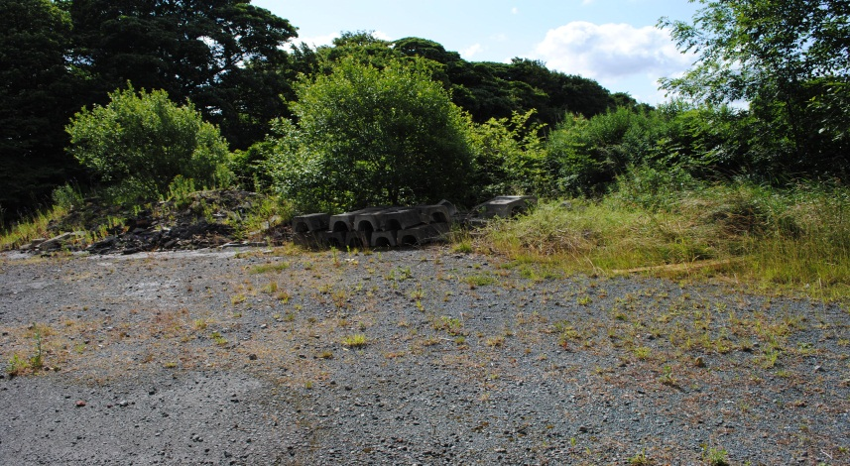

One of our aspirations is to continue to press for Sheffield City Council to make improvements to this eyesore. Ideas include the provision of raised flower beds & discrete storage facilities for BAT’s community equipment.

Your suggestions & support to improve the look of the site would be most welcome.

A WORD FROM THE TREASURER
“On behalf of BAT I would like to say thank you to local businesses for sponsoring the 23 floral areas we have created throughout Burncross. I would also like to say thank you for the individual private donations.
I hope you agree that Burncross looks a more welcoming and desirable place to live.”

It costs approximately £1,200 per annum just to maintain the high standards of the floral displays.

“Finally, I would like to give thanks to local people for all their hard work in planting the flowers, grass cutting, removing graffiti as well as the regular monthly litter picks. I hope you have fun on these occasions and enjoy making a contribution to your community.”
Together we can continue to improve the local area for the benefit of all.

SOME THOUGHTS FROM ONE OF OUR SPONSORS – JANINE SAVAGE OF BESPOKE IMPROVEMENTS LIMITED

“Our name is advertised on the flower box and on the BAT website. As a local community group BAT has been very successful and it is nice to be associated with success.
Customers might ask us what is BAT? What does it do? So we can advertise BAT as well as BAT advertising us. They see our sign on the flower box and our bright yellow vans and maybe connect the vivid colours with our business.
It’s difficult to assess just how successful our sponsorship is but clearly there has been an increased awareness of our business within the community.
It’s satisfying to know that for a small amount of money each year we are directly funding the improvement of our neighbourhood. They say that charity begins at home don’t they??”
KELLYS BLOG

As Chair of BAT I should like to thank Haybrook for their continued support in printing & distributing this newsletter, & in particular, Mike Rowbottom, the newly appointed Branch Manager at the Chapeltown office.

Also, I should like to welcome Amy the new Manager at the Acorn Inn who BAT intend to work with to put on future community events along with the Crown & Cushion and the Wharncliffe.

Some residents have expressed a concern about the different treatment of pavements in Burncross. I have therefore contacted the contractor “AMEY”, and this is what they have said -

“The treatment selected for each pavement is dependent on the condition of the pavement and how severe the deterioration is. Pavements that are in a reasonable condition, but are beginning to deteriorate on the surface, are suitable for a micro asphalt overlay. Pavements where the deterioration is more severe and the surface has worn away and is affected by cracking or is badly deformed require either resurfacing or reconstruction. The decision as to whether we resurface or reconstruct a pavement will depend on the condition and depth of the existing pavement.”

ADVANCE NOTICE OF THE BAT AGM

Please be aware the BAT annual general meeting this year will be held at the Wharncliffe Arms on the 16th of November. Public notices will be posted nearer this date.
We would very much like your support, thoughts and comments on our work and your community.

STREETS AHEAD

You will be aware of the work that has recently been undertaken on Burncross Road & we would like to let you know of future planned works in our area.

Information in respect of future planned work can be found on our website – www.burncrossactionteam.info

IN KIND SPONSORSHIP
Andy Wilkins gives up many hours of his spare time to tend to the grassed area on Nelson Place – Many thanks Andy

Newsletter sponsored by Haybrook Estate Agents (Chapeltown Branch):
http://www.haybrook.com/property-chapeltown.aspx

